Dear Parents,
I’m excited to tell you that on _______________________, author Lisa Maggiore of Chicago, IL, will visit our school to speak to students in (insert grades).
Ava the Monster Slayer: Cousin Power was drawn from her experience as a mom of a child who has an eye condition and has worn glasses since age two. Lisa brings an upbeat presentation full of personal stories, writing/publishing tips, and “insider information” about her book.

If you would like your child to have a book signed by the author, or if you want to order multiple books as gifts, please complete and return this form with payment to your child’s teacher. Lisa will sign and personalize each book. You are under no obligation to order a book, and Lisa will donate a copy to our school library.
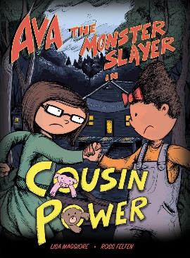
Thank you!
(LIBRARIAN/TEACHERS NAME)
Questions? (INSERT EMAIL)

“AVA THE MONSTER SLAYER; COUSIN POWER”
Written by Lisa Maggiore
Illustrated by Ross Felten

SUMMARY: When Ava and her cousin Sophia attend an overnight camp, they are scared, but take comfort in their beloved stuffed animals Piggy and Teddy being by their sides. After an evening hike the girls discover their beloved stuffed animals are gone! Ava knows they’ll have to face the ferocious creatures lurking in the woods if they want to rescue their favorite stuffed animals. 32 pgs. @2019 ISBN 978-1510748101 $15

✂ - - - - - - - - - - - - - - - - - - - - - - - - - - - - - - - - - - - - - - - - - - - - - - - - - - - - - - - - - - - - - - - - - -

AVA THE MONSTER SLAYER Book Order & Autograph Form
Book #1: Child’s Name (please print legibly):
□Check this box to verify that you want the book personalized by the author with your child’s name. If you prefer no personalization (signature only), please leave the box unchecked.
Please list other name(s) below if you are ordering additional copies that you would like personalized:
Name(s) for Book #2:
Name(s) for Book #3:
Please send cash or credit card information and return to your child’s teacher by [INSERT DATE]. Your child will receive his or her book(s) on the day of Lisa’s author visit.

Total Number of Books ___________ @ $15 each. Total amount owed __________
C.C. NUMBER: ____________________ EXP. DATE: __________ CODE: _________

